Mesa Street 24 inch Water Transmission Pipeline Replacement Project

Senior Engineering Design II – CE 4288

Group F

Eduardo Adame

Gerardo Garcia

Luis A. Hernandez

Mauricio Mar

Elvira M. Moreno

Jorge Valdez

December 2011

Table of Contents

Introduction 1

Objectives 2

Pipeline Route Description 3

Comparison of Materials 4

DIP vs PVC 4

DIP vs Steel Pipe 5

DIP vs SCCP 5

DIP vs HDPE 5

Geotechnical and Soils Investigation Report 6

Topographic Profile 8

Hydraulic Analysis 9

TCEQ Minimum Pressure Requirement 11

EPWU Hydraulic Flow Limiting Factors 12

Fire Protection Scenario 13

Valves 14

Thrust Restraint 17

Thrust block 17

Restrained Joints 21

Pipe Laying Condition and Embedment 24

Pipeline Casing under TxDOT Right of Way 25

Soil Corrosively Considerations 27

Traffic Control Plan 29

Pumping and Material Cost Analysis 38

Conclusions 40

References 41

Appendix 44

List of Tables

Table 1 – Soil Classification Provided by CQC Testing and Engineering 7

Table 2 – Soil Corrosivity Considerations 7

Table 3 – Material Selection and Properties Considered for the Hydraulic Analysis 9

Table 4 – Fire Flow Protection Results 14

Table 5 – Horizontal Bearing Strengths 19

Table 6 – Considered Soil Type and Soil Bearing Strength for Thrust Block Calculations 20

Table 7 – Trust Calculation Results 20

Table 8 – Cohesive Granular Soil and Sand or Gravel with Silt Data 22

Table 9 – pH Values Obtained from the Geotechnical Report 27

Table 10 – Recommended Advanced Warning Sign Minimum Spacing 31

Table 11 – Taper Length Criteria for Temporary Traffic Control Zones 31

Table 12 – Stopping Site Distance as a Function of Speed 31

Table 13 – Formulas for Determining Taper Length 32

Table 14 – Unit Head Loss Calculation for All Materials 38

Table 15 – Present Worth Calculation for Annual Cost 38

Table 16 – Summary Table with Total Initial Cost 39

List of Figures

Figure 1 – New Route Proposed for the Water Transmission Line 3

Figure 2 –Approximate Location of Exploration Borings 6

Figure 3 – Topographic Profile and Location of Utilities 8

Figure 4 – Route Modeled by EPANET Software for the New Water Transmission Line 10

Figure 5 – Pump Curve Created by Given Conditions 10

Figure 6 – Hydraulic Analysis Shown from Station 72 + 00 to 80 + 00 11

Figure 7 – Velocities Obtained the Different Materials 12

Figure 8 – Unit Head Loss Calculated for the Different Materials 12

Figure 9 – Ductile Iron Pipe (C200) Pressure Profile 13

Figure 10 – Final Design and Placement of Valves for the New Transmission Line 16

Figure 11- Thrust Force Layout 17

Figure 12 – Bearing Block Design 18

Figure 13 – Considered Soil Distribution 19

Figure 14 – Different Types of Restrained Push-On Gasket Joints 21

Figure 15 – Tees 23

Figure 16 - Laying Conditions Chosen for Ductile Iron Pipe 24

Figure 17 – Cross-sectional View of Casing and Carrier Pipes with Spacers/Isolators 26

Figure 18 – Cathodic Polarization vs % Corrosion Rate 28

Figure 19 – A Flagger with a STOP/SLOW Paddle 32

Figure 20 – Street Signs and Channeling Devices Specifications 32

Figure 21 – Traffic Control Plan 1 33

Figure 22 – Traffic Control Plan 2 34

Figure 23 – Traffic Control Plan 3 35

Figure 24 – Traffic Control Plan 4 36

Figure 25 – Traffic Control Plan 5 37

Abstract

Under the guidance of our mentor Mr. Floyd Johnson, P.E. from Huitt-Zollars Inc., our Senior Design team worked on the development of plans for a 24 inch water transmission replacement pipeline that currently runs along Mesa Street in El Paso, Texas. The El Paso Water Utilities (EPWU), owner of the water transmission system, decided to replace the pipeline due to recurrent pipe breaks caused by water hammering and aging of the pipe. The new transmission pipeline must meet the peak supply demands required for the area in addition to the required minimum flow rates for fire protection. Due to these demands, five different materials were considered for the design of the pipeline: Polyvinyl Chloride Pipe (PVC), Steel Pipe (SP), Ductile Iron Pipe (DIP), Pre-stressed Concrete Cylinder Pipe (PCCP), and High Density Polyethylene (HDPE). The objective of our Senior Design project was to determine which material would meet the demands while being the most cost efficient and long term effective option as well as developing a traffic control plan to ease the flow of traffic during construction.

# Introduction

The 24 inch water transmission pipeline supplies water to the west El Paso area adjacent to Mesa Street between Belvidere Street and Festival Drive including the areas adjacent to Resler Drive, Thunderbird Drive, Sunland Park Drive, and Mesa Hills Drive. The existing transmission line was installed in 1966 and has ruptured 14 times over the past 35 years. Because of the Texas Department of Transportation’s (TxDOT) restrictions on pipeline placements under state highways, an alternative, less trafficked route was chosen by EPWU north of the old route. Completion of the replacement is to be constructed in four phases, as requested by EPWU, with the first phase running from the Fred Miller Reservoir to Camille Drive. This first phase was the objective of the project, running approximately 9800 feet long.

The project will be completed following the EPWU and Texas Commission on Environmental Quality (TCEQ) standards in addition to those of the City of El Paso. The velocity of water in the pipeline will have a maximum range between four to five feet per second and the maximum rate of head loss due to friction will be five to seven feet per thousand feet. In addition, a requirement of a minimum pressure of 35 pounds per square inch shall be fulfilled.

# Objectives

The objectives of the project consisted of:

* Comparing material properties
* Developing a hydraulic analysis of the materials
* Designing truss restraint for the pipeline fittings
* Analyzing corrosivity considerations
* Designing/analyzing steel casing for carrier pipe
* Designing a traffic control plan
* Performing a cost analysis

# Pipeline Route Description

The transmission water line begins at the Fred Miller Pump Station and ends at the water line connection located on Camille Road, shown in Figure 1. The route of the pipe crosses the El Paso Natural Gas Company and the Westside Library parking lot up to Belvidere Drive. The line then goes down Belvidere Drive and after 200 feet turns east through the southern side of the Coronado Christian Church property. It continues east through the northern side of the Colony Cove I and II Shopping Centers and Albertsons grocery store up to Resler Drive. The line crosses Resler Drive and continues east on Cloudview Drive up to the eastern side of Irvin J. Lambka Park. It crosses the park going towards Colina Alta Drive following up to Fountain Drive, crossing it and going south in the western alley of Fountain Drive and up to Mesa Street. This new replacement crosses Mesa Street and ends at the Camille Road connection. The route was chosen by El Paso Water Utilities, and because of TxDOT’s restrictions and deficiency of geographic landscape, this route was considered the best alternative.

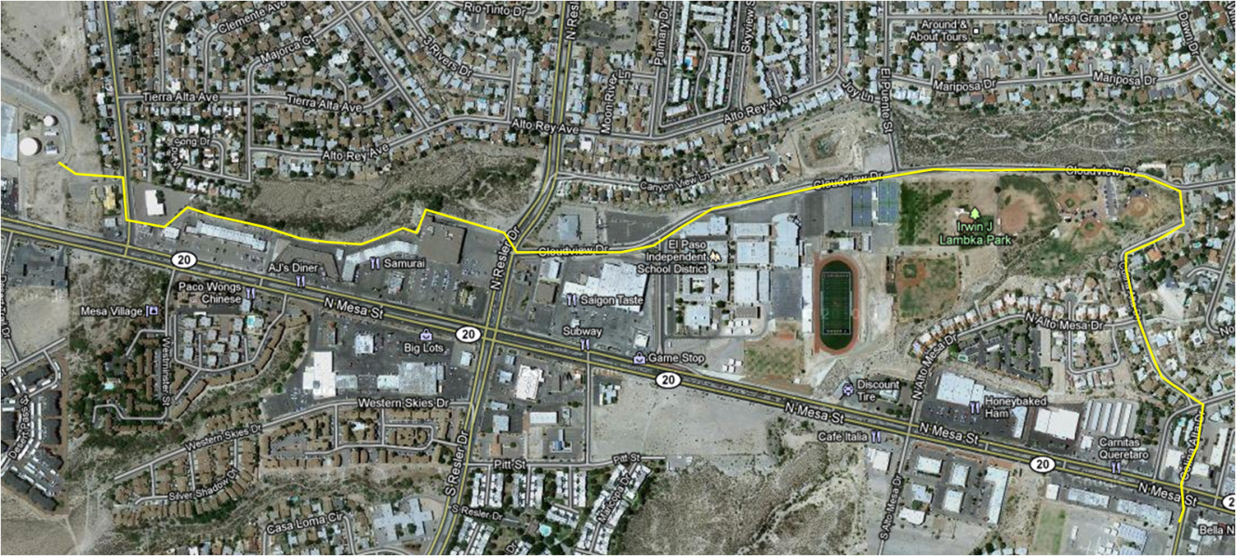

Figure 1 – New Route Proposed for the Water Transmission Line

# Comparison of Materials

After comparing all the approved materials, DIP was selected for the project. DIP is composed of an outer layer of asphaltic coating that protects the ductile iron against corrosion from exterior conditions and a cement mortar lining on the inside of the pipe that protects it from corrosion. Some of its advantages include it having a Hazen-Williams flow coefficient of 140 that is maintained over the life of the pipe and having an internal diameter larger than the nominal diameter. These two features yield a reduced head-loss in the system and thusly provide optimum service avoiding energy losses with the given pumping specifications. The following analysis compares each material to the chosen DIP with reasoning as to why it is a superior choice. This analysis was based on information provided in the Ductile Iron Pipe Research Association (DIPRA) website.

## DIP vs PVC

After comparing PVC to DIP, DIP was found to have more than eight times the tensile strength of PVC and resists up to four times the hydrostatic burst pressure, meaning that it better resists forces caused by internal hydrostatic pressure and water hammering. DIP is an all-around stronger and more durable material, with PVC considered a much “softer” material, therefore more vulnerable to scratches and damage. Although damages may go unnoticed during the installation of the pipe, this can later result in failures in the operating pipeline. This subsequent weakness necessitates PVC to require nearly three times the support from backfill as does DIP when installing the pipe. Another disadvantage to PVC is that restrained joints are not readily adaptable to this material thus limiting the joints available to use.

## DIP vs Steel Pipe

According to DIPRA, the prominent difference between DIP and steel pipe is the relative way their internal pressure designs are modeled. DIP has an incredibly conservative standardized design procedure, as opposed to steel pipe, and offers and impressive safety factor of 2.0 in the design pressure, whereas steel pipe uses a safety factor as low as 1.33. In the field, DIP is easier to install, more adaptable than steel pipe, and offers a simple corrosion control system since steel pipe needs more anti-corrosion measures. Another advantage of DIP over steel pipe is that pumping costs are lower, thus saving the system owner money throughout the life of the pipeline.

## DIP vs PCCP

In the comparison between DIP and PCCP we found that PCCP is similar to steel pipe from the standpoint of internal pressure design, installation, field adaptability, pumping costs, and operation and maintenance control. It also requires more corrosion control than DIP. This information was used to eliminate it as an option for the pipeline.

## DIP vs HDPE

Lastly, DIP was compared to HDPE and it was found that DIP better resists the forces caused by internal hydrostatic pressure and water hammering because it has more than 24 times the tensile strength of HDPE. Ductile iron was also found to have 12 times more impact strength proving it to be more durable. DIP compared to HDPE also has a larger inside diameter, which results in a lower head loss and higher energy savings. During construction, bedding is more critical in HDPE than in DIP because deflection must be controlled.

# Geotechnical and Soils Investigation Report

The geotechnical and soils investigation report was performed by CQC Testing and Engineering (CQC), a local engineering firm. This report is dated December 30, 2010 and it presents the results of field tests, soil exploration boring logs, soil laboratory classification test results, recommended soil bearing capacity values, and guidance information with respect to site preparation, structure embedment, soil backfilling, and trench safety considerations.

Six exploration borings were taken throughout the route; Figure 2 is an aerial view representing the location of these borings. Soil classifications were performed by CQC and are reported in Table 1.

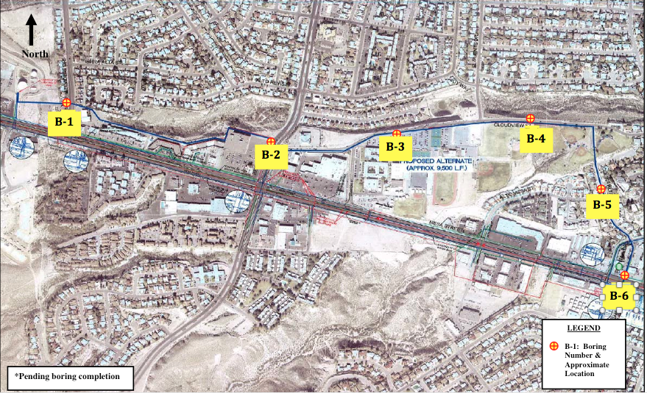

Figure 2 –Approximate Location of Exploration Borings

Table 1 – Soil Classification Provided by CQC Testing and Engineering



Additional parameters reported by CQC include boring depth and soil pH and are shown in Table 2; these parameters were used for corrosion and cathodic protection design considerations.

Table 2 – Soil Corrosivity Considerations

|  |  |  |
| --- | --- | --- |
| Borehole No. | Sample Depth (ft) | pH |
| B-1 | 2.5 – 4 | 8.6 |
| B-2 | 5 – 6.5 | 8.7 |
| B-3 | 2.5 – 4 | 8.6 |
| B-4 | 5 – 6.5 | 8.6 |
| B-5 | 2.5 – 4 | 8.7 |

# Topographic Profile

The topographic analysis showed that the highest elevation of the route occurred between Station 74 + 00 and Station 76 + 00 with an elevation of 4119.00 feet and the lowest elevation of 3912.50 feet occurred at the beginning of the route. Existing gas lines, sanitary sewer lines, water lines, box culverts, and storm drains were encountered along the route. Figure 3 shows the topographic profile. A more detailed view of this profile is located in the Appendix.

Figure 3 – Topographic Profile and Location of Utilities

# Hydraulic Analysis

The hydraulic analysis was conducted by simulating possible peak conditions for a 2015 summer day. EPWU provided the following information required to simulate peak conditions for the Fred Miller Booster Station: Demand = 5190.18 gallons per minute, Pump Elevation = 3,884 feet, and System Head = 4,192.17 feet.

In addition to the EPWU conditions, the Fred Miller reservoir provides further pressure from the elevation of water in the tank. A water elevation of 15 feet was used. Such elevation provides static pressure to the modeled system and increases the total system head. The total system head will be provided by pump and static pressure created by water elevation.

As previously mentioned, five different materials were considered for the hydraulic analysis: DIP, SP, PCCP, PVC, and HDPE. Information required for the hydraulic analysis with these materials is listed in Table 3. The C Factor refers to the Hazen –Williams Roughness Coefficient.

Table 3 – Material Selection and Properties Considered for the Hydraulic Analysis

|  |  |  |
| --- | --- | --- |
| Pipe Material | C Factor | Actual Inside Diameter (in) |
| DIP | 140 | 24.95 |
| Steel | 140 | 24.00 |
| PCCP | 140 | 24.00 |
| PVC | 150 | 22.76 |
| HDPE | 155 | 20.83 |

The hydraulic analysis was modeled and performed by EPANET 2.0 software, provided by the Environmental Protection Agency website. The system was modeled by installing junctions and links, simulating the route and the pipeline. Then a reservoir and a pump were introduced to the simulation in order to provide flow and system head. Figure 4 shows the route modeled in the software. The distribution system was modeled by inducing a pump curve which relates the combination of head and flow the pump can produce. The software automatically produces such a curve when pump conditions are established for the desired scenario. Figure 5 shows the pump curve utilized for the modeled distribution system.

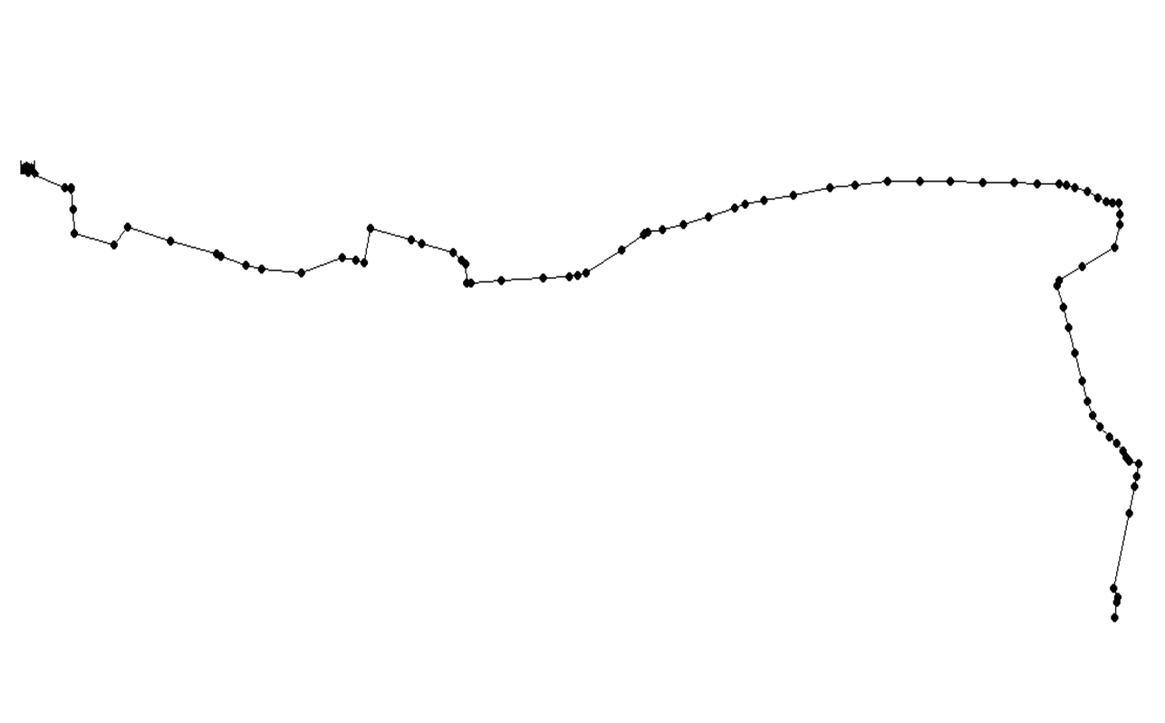

Figure 4 – Route Modeled by EPANET Software for the New Water Transmission Line

Figure 5 – Pump Curve Created by Given Conditions

## TCEQ Minimum Pressure Requirement

According to the TCEQ, Emergency Preparedness Plan, 290 Subchapter D, a water distribution system shall maintain a minimum pressure of 35 pounds per inch square at all points of the distribution network, in addition to a minimum of at least 1.5 gallons per minute per connection. The distribution network was modeled and as previously mentioned, a hydraulic analysis was performed with the five different materials. As shown in the topographic profile, the highest point of elevation is 4119.0 feet at the centerline of the proposed pipe. Thus, the lowest pressure is expected to occur at this point. Figure 6 shows the pressure obtained for the five different materials from station 72 + 00 to 80 + 00 where the lowest pressure was expected to occur.

TCEQ Restrictions

Figure 6 – Hydraulic Analysis Shown from Station 72 + 00 to 80 + 00

As depicted in the graph, all materials meet with the minimum pressure required. However, it is important to mention that HDPE shows the minimum pressure at the lowest point in comparison to all other four materials. Also, the hydraulic analysis states that DIP holds the maximum pressure at all points compared to the other materials.

## EPWU Hydraulic Flow Limiting Factors

The restrictions for water transmission mains provided by EPWU are as follows: a maximum rate of head loss due to friction in a transmission main to be five to seven feet per thousand feet, and that velocity in transmission mains must not exceed four to five feet per second. Figure 7 and 8 show the velocities and unit head loss resulting from the hydraulic analysis.

EPWU Limiting Velocity

Figure 7 – Velocities Obtained the Different Materials

EPWU Limiting Unit Head loss

Figure 8 – Unit Head Loss Calculated for the Different Materials

As shown in Figure 7, PVC and HDPE materials exceed the velocity restriction due to the relatively small inside diameter compared with the other materials. Figure 8 shows that all materials have a head loss well below the maximum rate of head loss allowed by EPWU standards.

According to the hydraulic analysis results, DIP represents the best alternative for the project, since it has the lowest unit head lost and shows the greatest pressure compared to the other materials. Figure 9 depicts the pressure profile obtained for DIP, pressure class 200 (C200).

Figure 9 – Ductile Iron Pipe (C200) Pressure Profile

## Fire Protection Scenario

According to TCEQ and National Fire Protection Agency (NFPA), the water distribution system runs under a zone defined as “light commercial” area. Therefore, for a fire protection scenario, a flow of 1,500 gallons per minute will have to be provided in addition to the normal distribution demands. Pressure in the system is required to be above 20 pounds per inches square at all points in the network. Table 4 includes the fire flow protection results from the system. Static pressure refers to the pressure available at the node with a normal demand. Residual pressure refers to the pressure available after the fire protection flow is drawn from the network.

Table 4 – Fire Flow Protection Results

|  |  |  |  |
| --- | --- | --- | --- |
| Node at Lowest Elevation | | Furthest Node from Booster Station | |
| Static Pressure | Residual Pressure | Static Pressure | Residual Pressure |
| 40.17 psi | 38.61 psi | 84.91 psi | 83.08 psi |

## Valves

For the design of this project, four different types of valves were used: flow valves, air release valves, vacuum relief valves and blow off valves. Flow valves are mainly valves used to close or open water flow through the pipe network. The flow valves chosen for this project were butterfly valves because they have a lower cost, they are lighter, and they do not require additional support.

Air release valves are also to be used in the pipe network. An air release valve is used in order to automatically drain quantities of air that are collected in a system at its higher points once the system is filled up and pressurized. The valve is composed primarily by a chamber and a float, as air bubbles enter into the chamber they will displace the level of water and lower the float until the valve orifice opens. Once the valve opens, air is dropped out the pipe and closed again by water pressure.

Another type of valve used in this design was vacuum release valve. Vacuum release valves allow the exhaust of volume of air from the system and also allow air to reenter the system when it is being emptied, in order to avoid negative pressures in the system. Such valves are also composed of a chamber and a float, when the system is filled up with liquid, the fluid lifts the float until it closes the valve. The valve is to remain closed until the system is emptied. The valve stays closed because of internal pressure; however, once internal pressure drops to near atmospheric pressure, the valve will reopens. Moreover, it is recommended to use a combination of air – vacuum release valves which function as a combination of both valves in only one.

Blow off valves will also be installed in the network. Blow off valves allow the pipeline to exhaust pressure when it reaches critical levels. According to the manufacturer Crosby Valve Inc., such valves are recommended to be positioned at the locations where the highest pressure occurs or where the lowest elevations happen.

The butterfly valves will be positioned every 1000 feet starting from station 0 + 00. Also, there will be a butterfly valve placed after a demand (pipe tee) is encountered in the pipe. This was done since it is better to divide the pipe in smaller sections in case of a closure for a repair.

Air and vacuum release valves will be positioned following manufacturers specifications. According to the manufacturer (Vent–O–Mat series RBX), three inch diameter valves will be required to meet pipeline flow and pipe diameter. The selection method can be found in the Appendix.

The following parameters were considered for the positioning of air release and vacuum relief valves: negative breaks (increase in downward slope or decrease in upward slope), long horizontal sections (1500 feet maximum), long ascending sections (1500 feet maximum), long descending sections (1500 feet maximum), and apex points (high points along the route).

Figure 10 shows the topographic profile with the locations of blow off valves, air / vacuum release valves, and flow valves.

Figure 10 – Final Design and Placement of Valves for the New Transmission Line